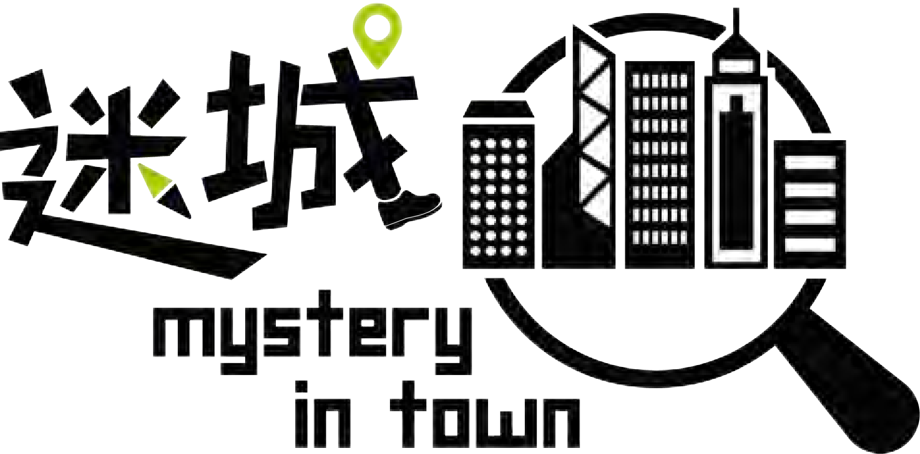主辦 Organiser:
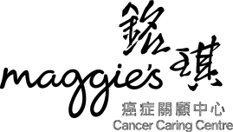

截止日期 Deadline:
27.02.2020 (星期四 Thursday) /
直至名額已滿 till the quota is full

城市定向慈善賽 - 隊伍參賽表格 (公開組)
Charity City Hunt - Team Registration Form (Public)
*名額有限，先到先得，請儘早報名！Limited Quota. Please register NOW !

請填妥此參賽表格，並連同劃線支票或銀行收據寄回或發送電郵至銘琪中心籌募及傳訊部。
Please fill in this registration form together with cheque or bank slip, and return to the Fundraising & Communications Unit at Maggie's Centre by post or email.

日期 Date
時間 Time

路線 Route
參賽形式 Game Format
2020 年
開幕典禮 Kick-off Ceremony 遊戲 Game
頒獎典禮 Prize-giving Ceremony
屯門 Tuen Mun
以隊制形式進行，每隊二至四人
Work in teams, 2 to 4 persons per team

待定

備註: 除冠亞季軍外，賽事亦特設「善心爆棚偵探獎」及「至型至charm偵探獎」，歡迎積極競逐獎項。詳情請參閱附件。
Remarks: Apart from Champion, 1st and 2nd runner up, you are highly encouraged to compete for "Top Fundraising Award" and "Best Costume Award". Details please refer to the Appendix.

公司/ 機構名稱 Company / Organisation Name
捐款收據上之名稱
Name on donation receipt

地址 Address

聯絡人 Contact Person
聯絡電話 Telephone
電郵 E-mail Address
❏ 我希望接收銘琪中心通訊 I would like to receive news from Maggie’s Centre.

捐款資料 Donation Details
❏ 參賽隊伍數目 No. of teams: __________ x HK$2,000 = HK$ ________________
❏ 現金捐贈 Cash Donation HK$ ________________________________________
總計 Total: HK$ _________________________________________
捐款方法 Donation Methods
❏ 支票 (支票抬頭「銘琪癌症關顧中心」，請於信封面註明「迷城」)
By cheque (made payable to “Maggie’s Cancer Caring Centre”, please mark "Mystery in Town" on the envelope)
❏ 直接存款 (匯豐銀行戶口︰808-327399-292)
By direct transfer into HSBC account (No.: 808-327399-292)
參賽者資料 Participant Details
所有參加者均須年滿18歲或以上。如參賽隊伍多於一隊，請自行複印表格填寫。
All participants must be aged 18 or above. Please make photocopies of this form if there are more than one participating team.
隊伍名稱 Team Name:

 | 姓名  Name | 電郵  Email | 聯絡電話  Contact no. | 性別  Gender
隊長
Leader
隊員
Member
隊員
Member
隊員
Member

聲明 Disclaimer
本團隊謹此聲明︰我們身體健康及有能力參加此活動。我們並同意將遵守主辦機構所定之活動安排、條文及規則。我們充分了解此活動的性質和範圍，並了解參與此活動的潛在風險。我 們自願參加此活動和願意承擔一切在活動期間因意外引起的責任，包括死亡、受傷或財物損失，本團隊將不會向主辦機構及／或贊助商對我們於活動中發生或其引致之自身意外、死亡、 財物損失或任何形式的損失索償或追討責任。

We certify that we are medically and physically capable of participation in this event. We agree to comply with all relevant rules and regulations and other arrangements made by the organiser. My team is fully aware of the nature and scope of this event and understands the potential risks inherent in such participation. My team knowingly and voluntarily assumes full responsibility for all risks arising out of or related to our participation in the event. We shall not hold the organiser and/or any sponsors responsible for any accident of whatsoever kind, resulting in death or injury, and/or any damage or loss or destruction of personal properties during the course of the event.

隊長簽署 Team leader's signature:
日期 Date:

聯絡我們 Contact Us
Fundraising & Communications Unit
☎ 9669 0148 (Whatsapp available) ✉ mysteryintown@maggiescentre.org.hk 🖷 2465 6063
香港新界屯門青松觀路屯門醫院銘琪癌症關顧中心
Maggie’s Cancer Caring Centre, Tsing Chung Koon Road, Tuen Mun Hospital, Tuen Mun, New Territories, Hong Kong

鬥智鬥勇 競逐獎項
Gear UP for the glory!

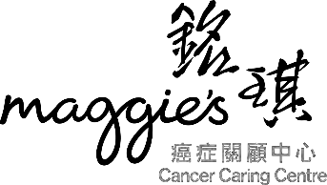每位參加者均可獲贈精美偵探主題禮品包乙個。

銘琪癌症關顧中心主辦
Maggie’s Cancer Caring Centre presents
迷城‧城市定向慈善賽
Mystery in Town·Charity City Hunt
Each participant will receive a detective goodie bag.

無敵神探獎  Best Detective Crew | 公開組︰優勝隊每位隊員可獲偵探主題獎牌乙個  Public Team: A detective medal will be awarded to
傑出偵探獎 亞軍
Outstanding Detective Crew
1st runner up
 | all members of the winning team
 | 企業組︰優勝隊伍可獲偵探造型獎杯乙個，及每位隊員可獲偵
 | 探主題獎牌乙個
傑出偵探獎 季軍
Outstanding Detective Crew
2nd runner up
 | Corporate Team: A detective trophy will be awarded to the
 | winning team and a detective medal will be awarded to
 | all members of the team
善心爆棚偵探獎 | 請各隊隊長於 2020年 2 月 27 日(星期四)或之前交回籌款表
Top Fundraising Award | 格及所收集之捐款證明 (以郵戳日期為準)，以便我們統計最高  籌款額。優勝隊伍可獲豐富獎品乙份
 | All team captains please submit this donation appeal form
 | and collected proof of donations to Maggie's Centre on or
 | before 29 November 2019, Friday (based on postmark date).
 | Each winning team will receive a prize
至型至charm偵探獎 | 參賽隊伍可於賽事當天穿戴具創意及特色的裝束，變身至型至 charm偵探，於城中穿梭破案。優勝隊伍可獲豐富獎品乙份
Best Costume Award | Let your creativity run wild! Participant could dress up as the
 | coolest and most charming detectives on the event day to
 | compete for The Best Costume Award.
 | Each winning team will receive a prize

